JSP
___________________________________________________________________________
JSP stands for java server pages and it is used for develop the dynamic web page and it is server side scripting language.

Q. Why use JSP if we have servlet for dynamic web pages?
________________________________________________________________________
1. JSP provide tags to us for generate the dynamic web content
2. Not need to write completed code for generate dynamic web pages.
3. Not need to complicated configuration like as servlet
4. Not need to create objects manually like as session ,cookie, ServletContext,ServletConfig etc
JSP provide some inbuilt object to us
5. Easy to integrate UI in dynamic web pages as compare with servlet
etc

Note: Every JSP internally work as servlet because when we run JSP page then internally JSP page convert in servlet by JSP container and servlet get compiled and executed by tomcat.

Q. What is JSP container?
___________________________________________________________________
JSP container is internal API present in web server which help to us convert jsp to servlet

How to work with JSP
_________________________________________________________________________
If you want to work with JSP we have following steps.

1. Create Project using standard folder structure of apache
Note: refer servlet folder structure
2. Create HTML page and save it using .jsp in root folder of project under web app
first.jsp
<html>
<head>
<title>jsp demo app</title>
</head>
<body>
<h1>good morning india</h1>
</body>
</html>
3. Execute or deploy or run the jsp page on tomcat

Syntax: http://localhost:pornumber/projectname/urlname

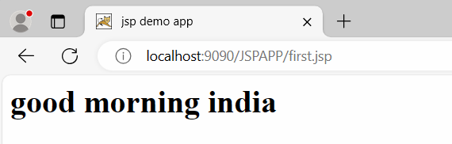
Note: After executing the JSP page it is internally convert in servlet.

Process of JSP to Servlet Conversion
_________________________________________________________________________

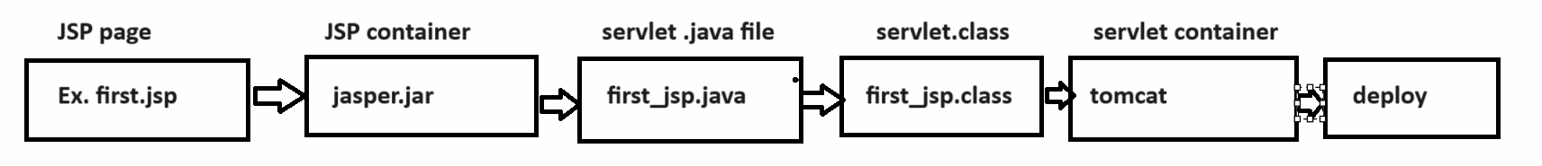

When your JSP convert in servlet then internally we get three methods which work as life cycle method of JSP

_jspInit(),
_jspService(final ServletRequest request,ServletResponse response)
_jspDestroy()

If we want to work with JSP we have some inbuilt tags provided by JSP to us and some inbuilt objects provided by JSP to us

Tags of JSP
____________________________________________________________________
Declaration: declaration tag in JSP is used for declare variable in jsp , or objects in jsp page etc
Syntax:
<%!
perform declaration here
%>
Example:
<%!
int a,b,c;
%>

Scriptlet: Scriptlet tag is used for writing logics in jsp like as for loop, if or any other logics
Syntax:
<% write here your logics
%>
Example:
<%
a=100;
b=200;
c=a+b;
%>
Expression: expression tag is used for display the output page on web page.
Syntax:
<%= expression %>
Example: <%=c%>
it is like as <% out.println(c); %>
Note: we cannot use semi colon in expression tag
<%=c;%>
it you give semi colon in expression tag it is consider <% out.println(c;);%>

Directive: directive tag is used for add the page specified attribute on JSP page , add external tag library in JSP page or include the another page content in JSP page.

Syntax: <%@attribute subattribute=”parameter” %>
There are three types of attribute of JSP page
1) Page 2 ) include 3) taglib
Note: we will discuss these attribute later in this chapter.

Objects of JSP
________________________________________________________________________________
out : this is inbuilt object of JspWriter class and it is child of PrintWriter internally and it is used for display the output on web page.

request: it is internally member of HttpServletRequest means we can use all methods of HttpServletRequest using request object.

response: it is internally object of HttpServletResponse
session: it is object of HttpSession interface
application: it is object of ServletContext
config: it is object of ServletConfig
page : page points to this member current working page object
context: it is object of PageContext
exception : it is inbuilt object of Exception

Note: these object we can use only within a service method means within scriptlet tag

Create JSP project using eclipse and declare two variables and calculate its addition and display it.

Steps.
1. Create Dynamic web project
2. Create JSP page under web app folder

<%@ page language="java" contentType="text/html; charset=ISO-8859-1"
pageEncoding="ISO-8859-1"%>
<!DOCTYPE html>
<html>
<head>
<meta charset="ISO-8859-1">
<title>Insert title here</title>
</head>
<body>
<!-- declaration tag -->
<%!
int a,b,c;
%>
<%
a=100;
b=200;
c=a+b;
out.println("Addition is "+c);
%>
</body>
</html>
Output:
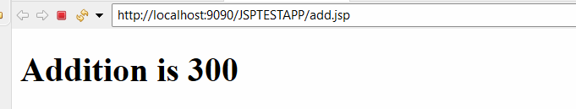
if we think about above code we calculate addition of fix values so we want to accept input from keyboard and then calculate addition.
so we design HTML form and provide input in form and submit to server then calculate addition
Source
add.jsp
<%@ page language="java" contentType="text/html; charset=ISO-8859-1"
pageEncoding="ISO-8859-1"%>
<!DOCTYPE html>
<html>
<head>
<meta charset="ISO-8859-1">
<title>Insert title here</title>
<style>
input{
width:400px;
height:40px;
border-radius:10px;
padding:10px;
}
</style>
</head>
<body>
<!-- declaration tag -->
<%!
int a,b,c;
%>
<form name='frm' action='' method='POST'>
<input type='text' name='first' value=''/><br/><br/>
<input type='second' name='second' value=''/><br/><br/>
<input type='submit' name='s' value='Calculate Addition'/>
</form>
<%
String btn=request.getParameter("s");
if(btn!=null){
a=Integer.parseInt(request.getParameter("first"));
b=Integer.parseInt(request.getParameter("second"));
c=a+b;
out.println("Addition is "+c);
}
%>
</body>
</html>
Output:
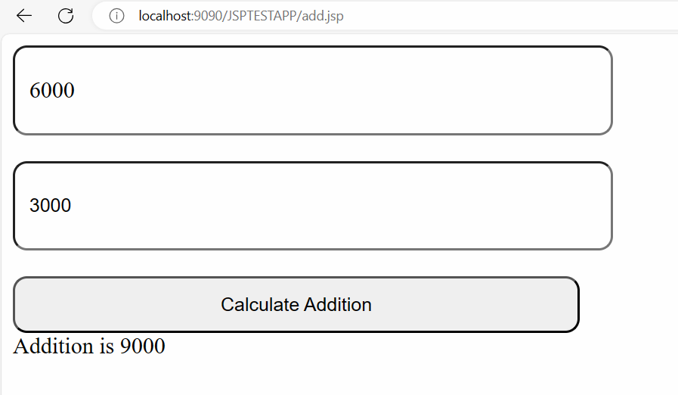

Example: WAP to design HTML page with single text box and button and input number in textbox and print its table.
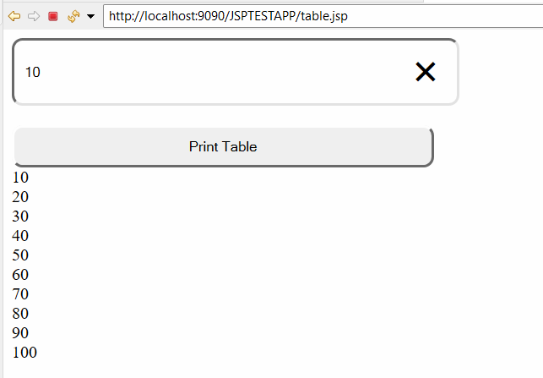
table.jsp
<%@ page language="java" contentType="text/html; charset=ISO-8859-1"
pageEncoding="ISO-8859-1"%>
<!DOCTYPE html>
<html>
<head>
<meta charset="ISO-8859-1">
<title>Insert title here</title>
<style>
input{
width:400px;
height:40px;
border-radius:10px;
padding:10px;
}
</style>
</head>
<body>
<%!
int no,tab;
%>
<form name='frm' action='' method='POST'>
<input type='text' name='num' value=''/><br/><br/>
<input type='submit' name='s' value='Print Table'/>
</form>
<%
String btn=request.getParameter("s");
if(btn!=null){
no=Integer.parseInt(request.getParameter("num"));
for(int i=1;i<=10;i++){
tab=i*no;
out.println(tab+"<br>");
}
}
%>
</body>
</html>

If we think about above code we print the table but we want to display table like as
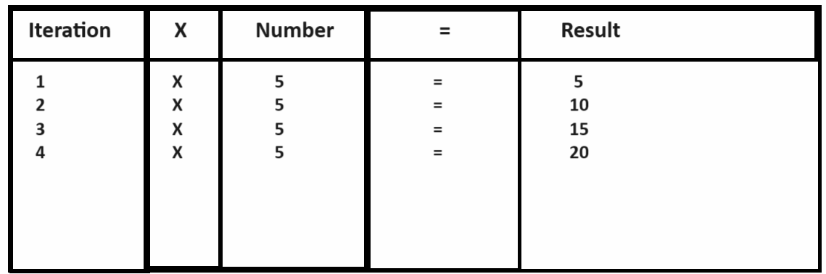
Note: if we want to show the output like as we need to generate dynamic HTML using JSP

How to generate dynamic HTML using JSP
______________________________________________________________________
If we want to generate dynamic HTML using JSP we have two ways
1. Generate using out.println () tag
_____________________________________________________________________
<%@ page language="java" contentType="text/html; charset=ISO-8859-1"
pageEncoding="ISO-8859-1"%>
<!DOCTYPE html>
<html>
<head>
<meta charset="ISO-8859-1">
<title>Insert title here</title>
<style>
input{
width:400px;
height:40px;
border-radius:10px;
padding:10px;
}
</style>
</head>
<body>
<%!
int no,tab;
%>
<form name='frm' action='' method='POST'>
<input type='text' name='num' value=''/><br/><br/>
<input type='submit' name='s' value='Print Table'/>
</form>
<%
String btn=request.getParameter("s");
if(btn!=null){
no=Integer.parseInt(request.getParameter("num"));
out.println("<table border='5' width='80%'>");
out.println("<tr><th>Iteration</th><th>X</th><th>Number</th><th>=</th><th>Result</th></tr>");
for(int i=1;i<=10;i++){
tab=i*no;
out.println("<tr>");
out.println("<td align='center'>"+i+"</td>");
out.println("<td align='center'>X</td>");
out.println("<td align='center'>"+no+"</td>");
out.println("<td align='center'>=</td>");
out.println("<td align='center'>"+(no*i)+"</td>");
out.println("</tr>");
}
out.println("</table>");
}
%>
</body>
</html>
2. Generate using Tag breaking Technique.
__________________________________________________________________
<%@ page language="java" contentType="text/html; charset=ISO-8859-1"
pageEncoding="ISO-8859-1"%>
<!DOCTYPE html>
<html>
<head>
<meta charset="ISO-8859-1">
<title>Insert title here</title>
<style>
input {
width: 400px;
height: 40px;
border-radius: 10px;
padding: 10px;
}
</style>
</head>
<body>
<%!int no, tab;%>
<form name='frm' action='' method='POST'>
<input type='text' name='num' value='' /><br />
<br /> <input type='submit' name='s' value='Print Table' />
</form>
<%
String btn = request.getParameter("s");
if (btn != null) {
no = Integer.parseInt(request.getParameter("num"));
%>
<table border='5' width='80%'>
<tr>
<th>Iteration</th>
<th>X</th>
<th>Number</th>
<th>=</th>
<th>Result</th>
</tr>
<%
for (int i = 1; i <= 10; i++) {
tab = i * no;
%>
<tr>
<td align='center' ><%=i%></td>
<td>X</td>
<td><%=no%></td>
<td>=</td>
<td><%=tab%></td>
</tr>

<%
}
%>
</table>
<%
}
%>
</body>
</html>
Output
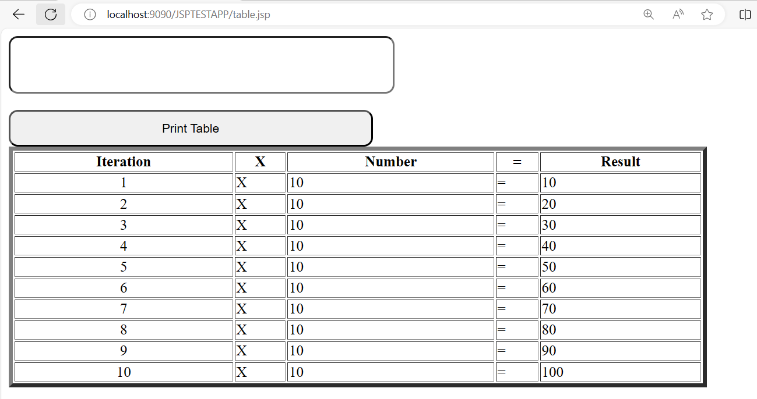

Directive Tags and its attribute
___________________________________________________________________________
Directive tags is used for apply page level attribute on jsp page as well as include another page content on jsp page and use the third party tag libraries in jsp

There are three types of attribute of Directives tag
___________________________________________________________________________________
1. page: Page directives is used for add the page level attributes on JSP page.
Syntax: <%@page attribute=”values” %>

Attribute of JSP page
__________________________________________________________________________________
import: this is sub attribute of page attribute of JSP page and which is used for import package in application.

<%@page import=”packagename,packagename” %>

Example: we want to create web page which is used for display system date on web page
Source code
<%@ page language="java" contentType="text/html; charset=ISO-8859-1"
pageEncoding="ISO-8859-1"%>
<%@page import="java.util.*" %>
<!DOCTYPE html>
<html>
<head>
<meta charset="ISO-8859-1">
<title>Insert title here</title>
</head>
<body>
<%!
Date d;
%>

<%
d = new Date();
%>
<h1>Today Date is <%=d%></h1>
</body>
</html>
Output:
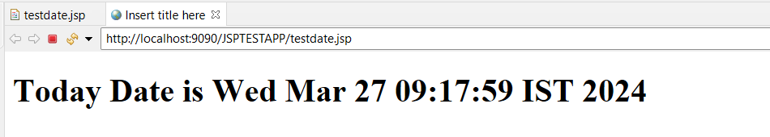
contentType: this attribute is used for decide the response type from server to client
by default it is text/html
Syntax: <%@ page language="java" contentType="text/html” %>

isErrorPage : isErrorPage is sub attribute of page and this page decide current page may be contain exception or not or may be generate run time exception or not if we set true the meaning is your current page may be generate exception at run time if we set false then current page not generate exception at run time.
errorPage: errorPage attribute set error page or target errorPage means when your working page generate exception at run time then server call error page
note: isErrorPage and errorPage attribute use at same time.

Example: we want to create application input two values and calculate its division
if think about division then there is possibility of exception if user input second value as 0 then JVM may be generate run time exception

Example:
div.jsp
<%@ page language="java" contentType="text/html; charset=ISO-8859-1"
pageEncoding="ISO-8859-1" isErrorPage="true" errorPage="error.jsp" %>
<!DOCTYPE html>
<html>
<head>
<meta charset="ISO-8859-1">
<title>Insert title here</title>
<style>
input{
width:400px;
height:40px;
border-radius:10px;
padding:10px;
}
</style>
</head>
<body>
<%!
int a,b,c;
%>
<form name='frm' action='' method='POST'>
<input type='text' name='first' value=''/><br/><br/>
<input type='second' name='second' value=''/><br/><br/>
<input type='submit' name='s' value='Calculate Division'/>
</form>
<%
String btn=request.getParameter("s");
if(btn!=null){
a=Integer.parseInt(request.getParameter("first"));
b=Integer.parseInt(request.getParameter("second"));
c=a/b;
out.println("<h1>Division is "+c+"</h1>");
}
%>
</body>
</html>

error.jsp
<%@ page language="java" contentType="text/html; charset=ISO-8859-1"
pageEncoding="ISO-8859-1"%>
<!DOCTYPE html>
<html>
<head>
<meta charset="ISO-8859-1">
<title>Insert title here</title>
</head>
<body>
<h1>Second value should not zero</h1>
</body>
</html>

session: this attribute decide session object can use on web page or not if we set false then we cannot use session object on web page and if set true then we can use session object on web page.

Syntax: <%@page session=”true | false” %>

Example:
<%@ page language="java" contentType="text/html; charset=ISO-8859-1"
pageEncoding="ISO-8859-1"%>
<%@page session="false" %>
<!DOCTYPE html>
<html>
<head>
<meta charset="ISO-8859-1">
<title>Insert title here</title>
</head>
<body>
<h1>Second value should not zero</h1>
<%
session.setAttribute("u", "Ramesh");

%>
</body>
</html>
Note: if we think about above code we have statement session.setAttribute(“u”,”ramesh”);
will generate error to us because we set session=”false” in directives tag means we disable session from this web page

charSet : this method is used for set uni code character set on web page like as
Syntax: <%@page charset=”charset” %>

Example:<%@ page language="java" contentType="text/html; charset=ISO-8859-1" %>

bufferSize : this attribute set the buffer size of web page
Syntax: <%@page bufferSize=”17kb” %>

isELIgnored: this attribute is used for decide expression language should use on web page or not
if we set false then we can use expression language on web page if we set true then we cannot use expression language on web page.

Syntax: <%@page isELIngored=”true | false” %>

language: language attribute decide language with jsp page.
Example: <%@page language=”java” %>

2. include: this attribute help us to include the another page content in JSP.
Syntax: <%@include file=”pagename” %>

Example: we want to use the common navigation bar in all jsp pages.

nav.jsp
___________________________________________________________
<%@ page language="java" contentType="text/html; charset=ISO-8859-1"
pageEncoding="ISO-8859-1"%>
<!DOCTYPE html>
<html>
<head>
<meta charset="ISO-8859-1">
<title>Insert title here</title>
<style>
ul{
list-style-type:none;
width:100%;
background-color:black;
padding:10px;
}
ul li{
display:inline;
padding:10px;
}
ul li a {
text-decoration:none;
color:white;
}
</style>
</head>
<body>
<ul>
<li><a href='add.jsp'>Addition</a></li>
<li><a href='div.jsp'>Division</a></li>
</ul>
</body>
</html>

add.jsp
<%@ page language="java" contentType="text/html; charset=ISO-8859-1"
pageEncoding="ISO-8859-1"%>
<!DOCTYPE html>
<html>
<head>
<meta charset="ISO-8859-1">
<title>Insert title here</title>
<style>
input{
width:400px;
height:40px;
border-radius:10px;
padding:10px;
}
</style>
</head>
<body>
<!-- declaration tag -->
<%!
int a,b,c;
%>
<%@include file="nav.jsp" %>
<br/>
<h1>Addition page</h1>
<form name='frm' action='' method='POST'>
<input type='text' name='first' value=''/><br/><br/>
<input type='second' name='second' value=''/><br/><br/>
<input type='submit' name='s' value='Calculate Addition'/>
</form>
<%
String btn=request.getParameter("s");
if(btn!=null){
a=Integer.parseInt(request.getParameter("first"));
b=Integer.parseInt(request.getParameter("second"));
c=a+b;
out.println("Addition is "+c);
}
%>

</body>
</html>
div.jsp
<%@ page language="java" contentType="text/html; charset=ISO-8859-1"
pageEncoding="ISO-8859-1" isErrorPage="true" errorPage="error.jsp" %>
<!DOCTYPE html>
<html>
<head>
<meta charset="ISO-8859-1">
<title>Insert title here</title>
<style>
input{
width:400px;
height:40px;
border-radius:10px;
padding:10px;
}
</style>
</head>
<body>
<%!
int a,b,c;
%>
<%@include file="nav.jsp" %>
<br/>
<h1>Division page</h1>
<form name='frm' action='' method='POST'>
<input type='text' name='first' value=''/><br/><br/>
<input type='second' name='second' value=''/><br/><br/>
<input type='submit' name='s' value='Calculate Division'/>
</form>
<%
String btn=request.getParameter("s");
if(btn!=null){
a=Integer.parseInt(request.getParameter("first"));
b=Integer.parseInt(request.getParameter("second"));
c=a/b;
out.println("<h1>Division is "+c+"</h1>");
}
%>
</body>
</html>
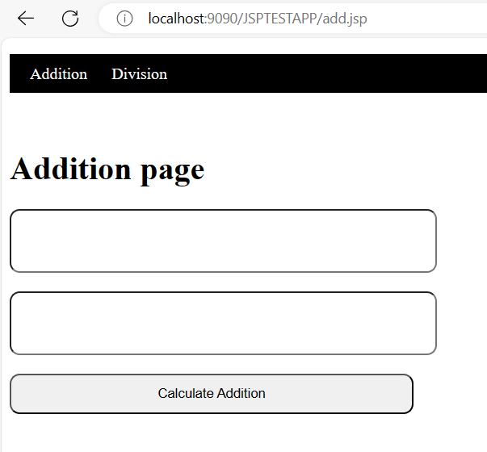

div.jsp
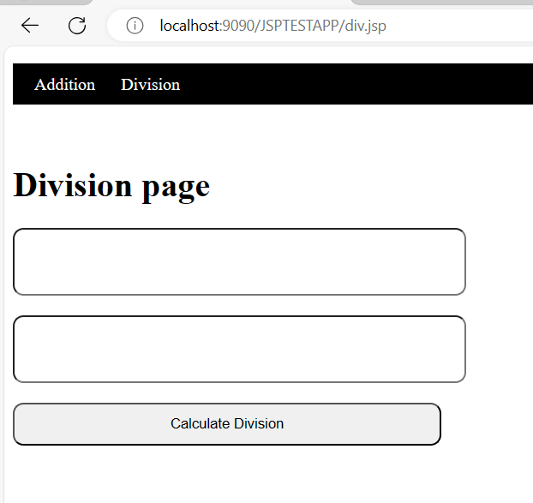
3. taglib: taglib directives is used for use third party tag library in jsp page like as JSTL,spring mvc form tag library etc

<%@taglib uri=”uri of page” prefix=”starting letter of tag” %>

uri: this attribute decide the uri of web page
prefix: this attribute decide starting letter of tag for use tag from tag library

